Design and Analysis of Algorithms
Week-2 Assignment
G VEDA KARTIK
CH.SC.U4CSE24212

Bubble Sort

PROGRAM:
#include <stdio.h> int main() {
int n;
printf("ENTER NO.OF.ELEMENTS:");
scanf("%d",&n); int arr[n];
printf("ENTER THE VALUES:");
for(int i=0;i < n;i++){ scanf("%d",&arr[i]);
}
for (int i = 0; i < n - 1; i++) {
for (int j = 0; j < n - i - 1; j++) { if (arr[j] > arr[j + 1]) {
int temp = arr[j]; arr[j] = arr[j + 1]; arr[j + 1] = temp;
}
}
}
printf("Sorted array: "); for (int i = 0; i < n; i++) {
printf("\t%d\t,",arr[i]);
}
return 0;
}

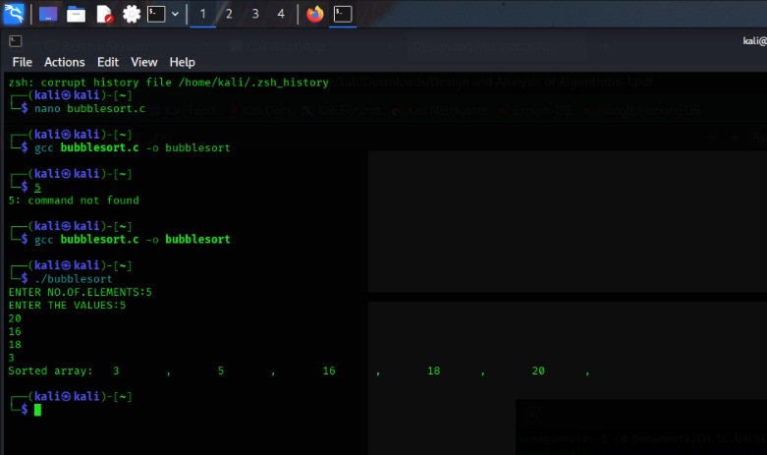

Insertion Sort
PROGRAM:
#include <stdio.h> int main() {
int n;
printf("ENTER NO.OF ELEMENTS");
scanf("%d",&n); int arr[n];
printf("ENTER THE ELEMENTS:");
for(int i=0; i <n;i++){ scanf("%d",&arr[i]);
}
for (int i = 1; i < n; i++) { int key = arr[i];
int j = i - 1;
while (j >= 0 && arr[j] > key) { arr[j + 1] = arr[j];
j--;
}
arr[j + 1] = key;
}
printf("Sorted array: "); for (int i = 0; i < n; i++) {
printf("%d ", arr[i]);
}
return 0;
}

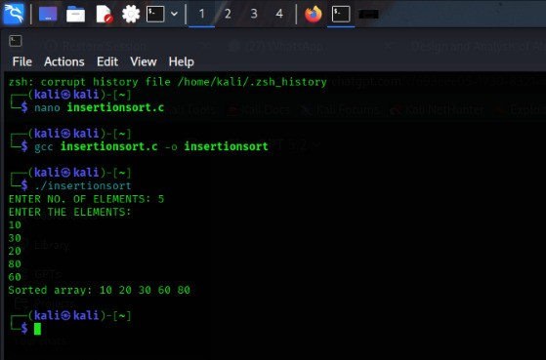

Selection Sort

PROGRAM:
#include <stdio.h> int main() {
int n;
printf("ENTER NO. OF ELEMENTS: ");
scanf("%d", &n); int arr[n];
printf("ENTER THE VALUES: ");
for (int i = 0; i < n; i++) { scanf("%d", &arr[i]);
}
for (int i = 0; i < n - 1; i++) { int minIndex = i;
for (int j = i + 1; j < n; j++) { if (arr[j] < arr[minIndex]) {
minIndex = j;
}
}
int temp = arr[i];
arr[i] = arr[minIndex]; arr[minIndex] = temp;
}
printf("Sorted array: "); for (int i = 0; i < n; i++) {
printf("%d ", arr[i]);
}
return 0;
}
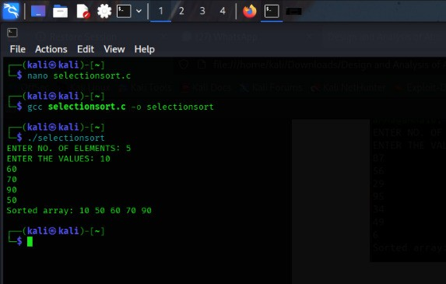

Bucket Sort

PROGRAM:
#include <stdio.h>
int main() { int n;
printf("ENTER NO. OF ELEMENTS: ");
scanf("%d", &n); int arr[n];
printf("ENTER THE VALUES (0 to 100): ");
for (int i = 0; i < n; i++) { scanf("%d", &arr[i]);
}
int bucket[101] = {0}; for (int i = 0; i < n; i++) {
bucket[arr[i]]++;
}
printf("Sorted array: ");
for (int i = 0; i <= 100; i++) { while (bucket[i] > 0) {
printf("%d ", i);
bucket[i]--;
}
}
return 0;
}
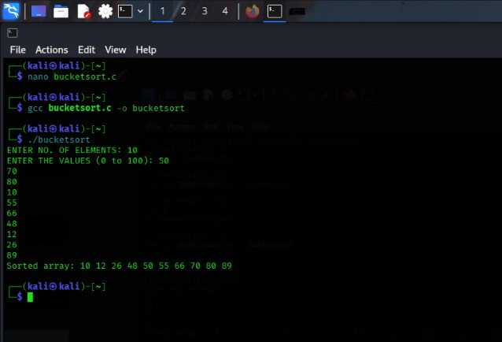

Heap Sort

PROGRAM:
#include<stdio.h> int main() {
int n;
printf("ENTER NO. OF ELEMENTS: ");
scanf("%d", &n); int arr[n];
printf("ENTER THE VALUES: ");
for (int i = 0; i < n; i++) { scanf("%d", &arr[i]);
}
for (int i = 1; i < n; i++) { int child = i;
while (child > 0) {
int parent = (child - 1) / 2;
if (arr[parent] < arr[child]) { int temp = arr[parent]; arr[parent] = arr[child]; arr[child] = temp;
child = parent;
} else {
break;
}
}
}
for (int i = n - 1; i > 0; i--) { int temp = arr[0];
arr[0] = arr[i]; arr[i] = temp; int parent = 0; while (1) {
int left = 2 * parent + 1; int right = 2 * parent + 2; int largest = parent;
if (left < i && arr[left] > arr[largest]) largest = left;
if (right < i && arr[right] > arr[largest])
largest = right;
if (largest != parent) {
int temp2 = arr[parent]; arr[parent] = arr[largest]; arr[largest] = temp2; parent = largest;
} else {
break;
}
}
}
printf("Sorted array: "); for (int i = 0; i < n; i++) {
printf("%d ", arr[i]);
}
return 0;
}
